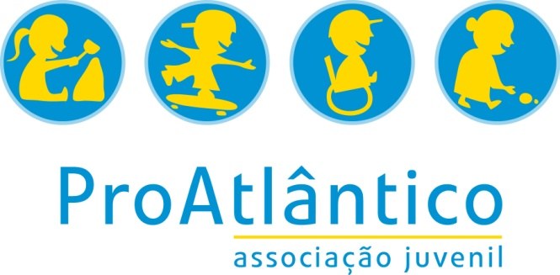

Name:

Personal questions
How would you describe your personality?

What are your hobbies?

Have you already travelled or lived abroad? If « yes » where, when, for what reason and for how long?

What are your strengths and weaknesses when relating to other people?

Do you have any special needs (allergies, health…)?

Did you have any serious medical problems in the past?

Do you have any food restrictions (vegetarian, allergies, etc)?

Fewer Opportunities
Please read the following information about fewer opportunities
Notice that this Program gives priority to people with fewer opportunities, so please indicate if you consider that you face any of those situations.
disability (i.e. participants with special needs): people with mental (intellectual, cognitive, learning), physical, sensory or other disabilities;

educational difficulties: young people with learning difficulties; early school-leavers; low qualified adults; young people with poor school performance;

economic obstacles: people with a low standard of living, low income, dependence on social welfare system or homeless; young people in long-term unemployment or poverty; people in debt or with financial problems;

cultural differences: immigrants or refugees or descendants from immigrant or refugee families; people belonging to a national or ethnic minority; people with linguistic adaptation and cultural inclusion difficulties;

health problems: people with chronic health problems, severe illnesses or psychiatric conditions;

social obstacles: people facing discrimination because of gender, age, ethnicity, religion, sexual orientation, disability, etc.; people with limited social skills or anti-social or risky behaviours; people in a precarious situation; (ex-)offenders, (ex-)drug or alcohol abusers; young and/or single parents; orphans

geographical obstacles: people from remote or rural areas; people living in small islands or in peripheral regions; people from urban problem zones; people from less serviced areas (limited public transport, poor facilities).

In case you chose one or more options above, please justify it:

Questions about the project
What is your main motivation to participate in this project?

What are your expectations?

What do you expect to learn?

Do you have any worries or fears about becoming an EVS volunteer?

Which challenges do you think you will encounter during your stay abroad?

How do you feel about working with people different from yourself (racial/ethnic background, developmentally disabled, different socio-economic backgrounds, different sexual orientation…)?

Are you ready to work 6 hours per day, 5 days per week?

Does your family and friends support your participation in this EVS project?

Are you interested in learning Portuguese in order to develop your tasks and to feel integrated in the local community?

Questions about logistical issues
The bedroom is always shared. How do you feel about share a room with other person?

How do you feel about live with people from different countries and cultures?

Dissemination of the project
As a volunteer, you are supposed to take part in events, presentations and conversations with Portuguese young people or future EVS volunteers to motivate young people to be more active or give visibility to their EVS project. Do you agree with this?

Do you understand you will have to take part in events to promote EVS that ProAtlântico realizes and you must use the clothes provided to that activity (t-shirt, cap, etc). Do you agree with this?

In the end of each month the volunteer is asked to make a testimony and to give some photos that will be publish in Medea (newspaper, facebook, ...) to promote EVS, and to make a video during the project about the EVS experience to be published in website, social networks, media or in other means of divulgation. Do you agree with this?

