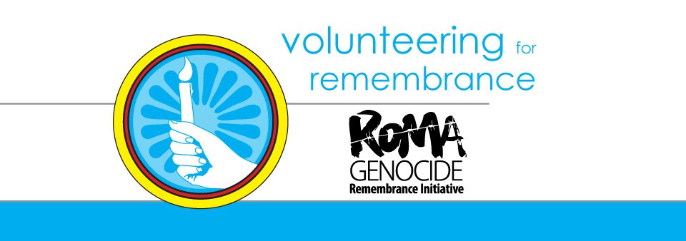

Volunteering for Remembrance!
Phiren Amenca seminar on remembrance and human rights education
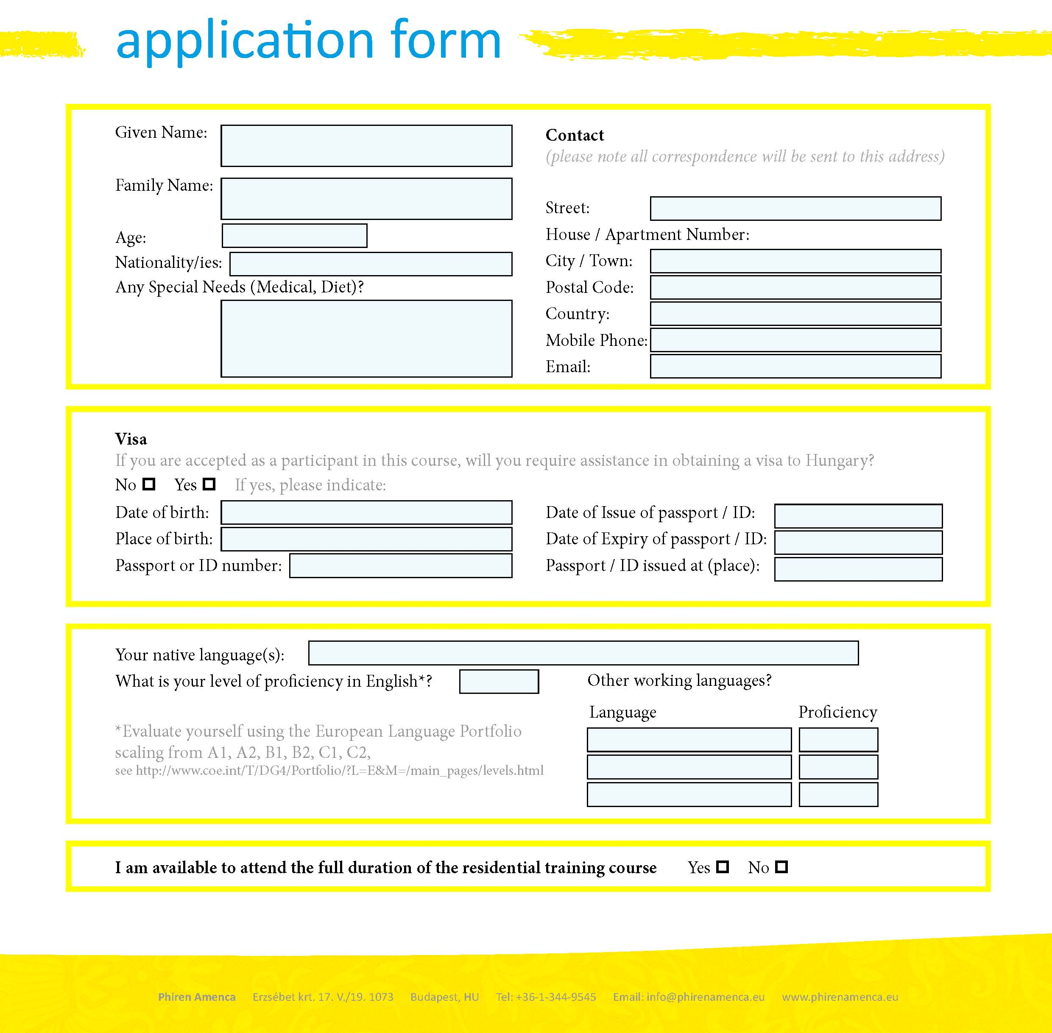
Romania, April 29 - May 6, 2015

International Voluntary Service:
Do you currently participate in an international voluntary service program such as the European Voluntary Service? Are you a former volunteer or interested in a voluntary service in the future? Please give the name of your project period (dates), your sending and your hosting organization:

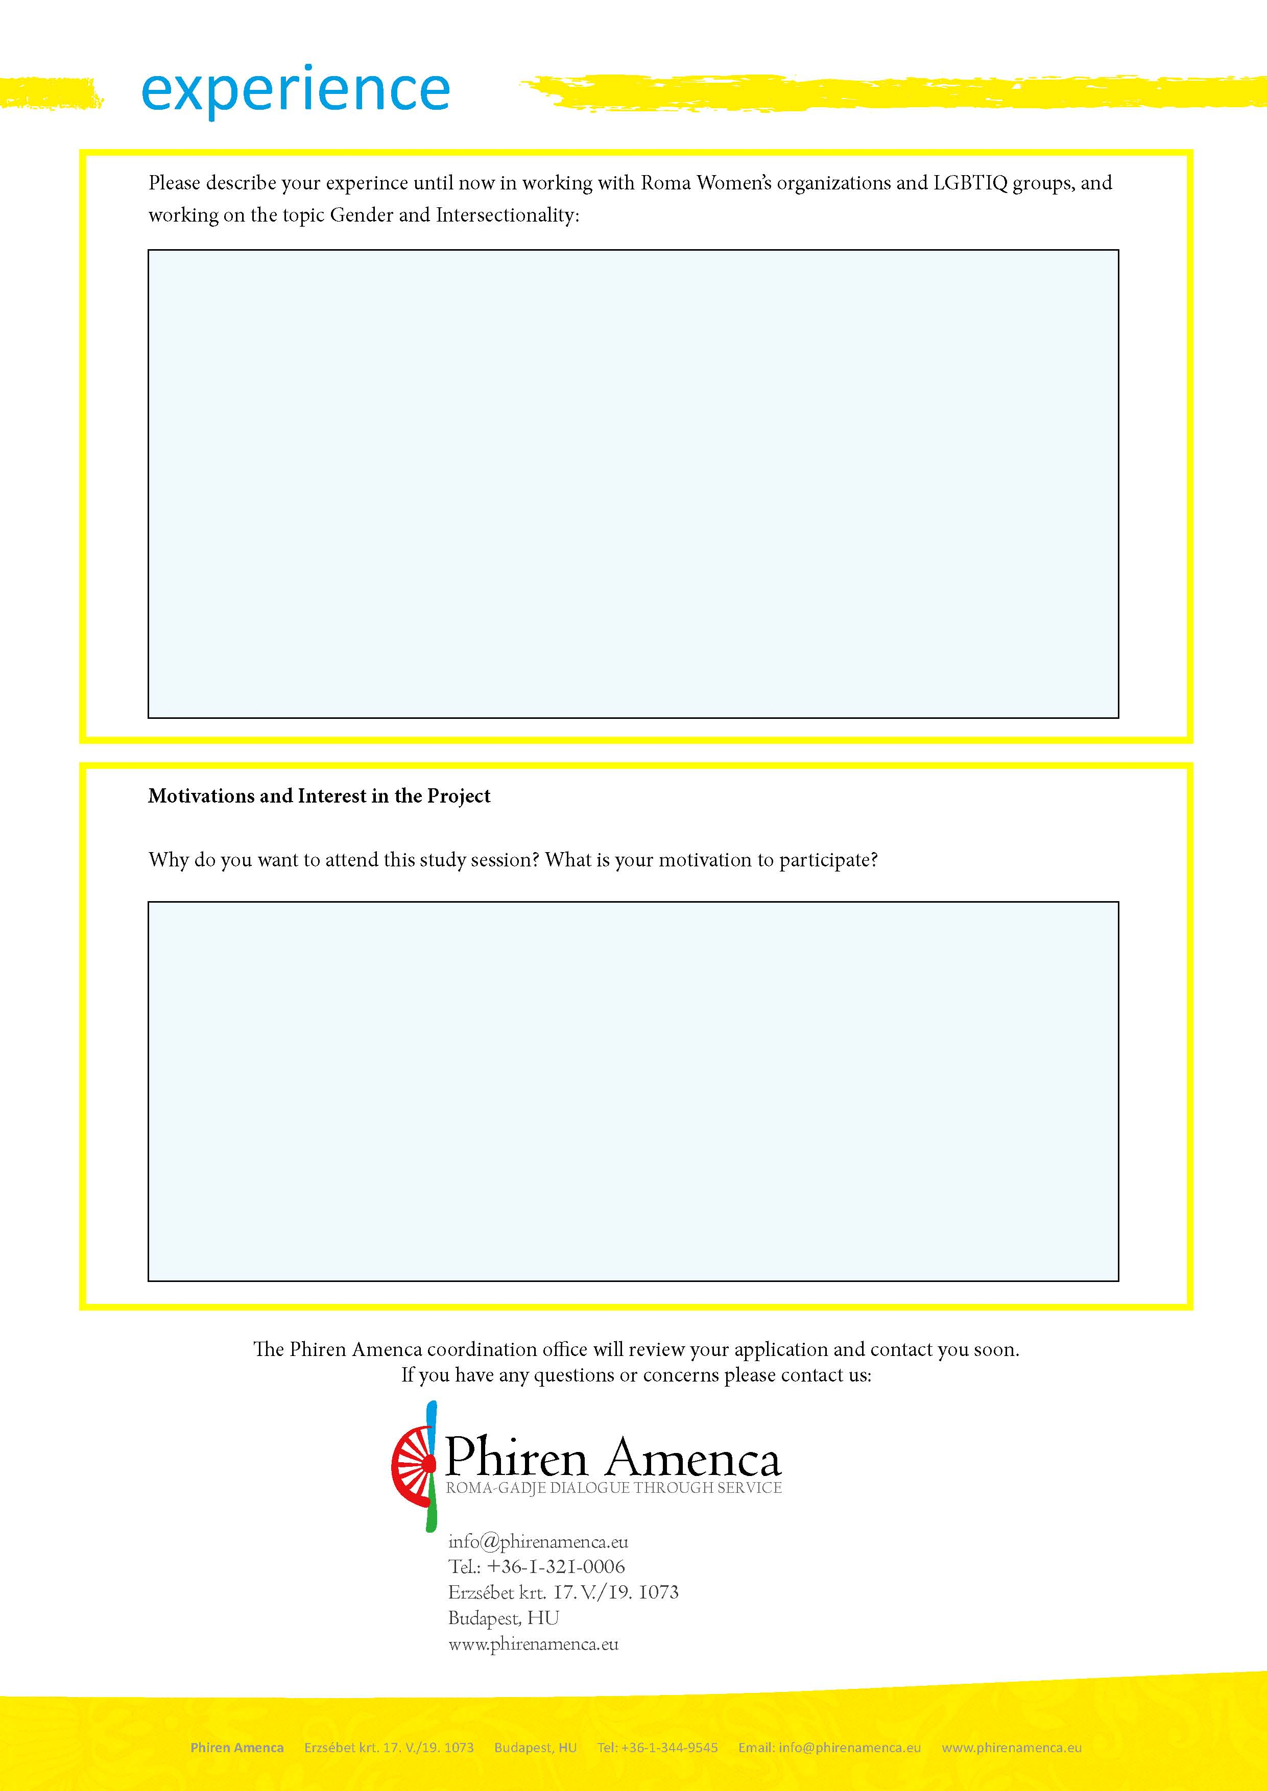
Please describe your experience until now on the topic of the Holocaust/Roma, as well as your experience in human rights education and challenging stereotypes and racism:

